**Lesson Plan/Format**

NAME Dina Hoeynck COURSE INSTRUCTOR

**I. PROJECT TITLE:**  Weather Books

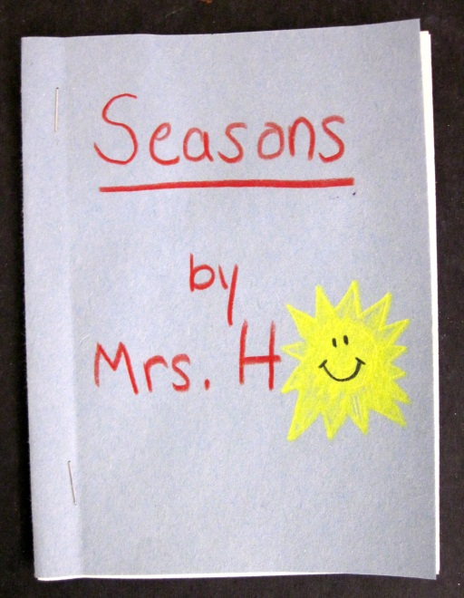 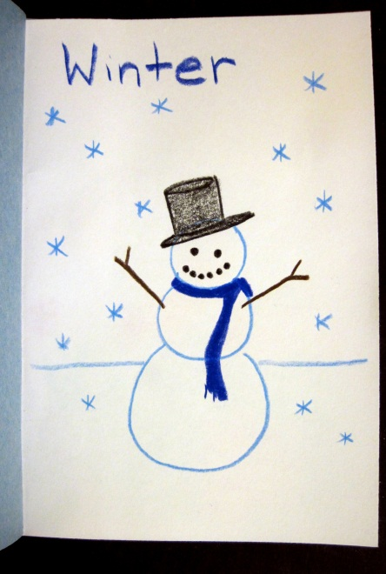 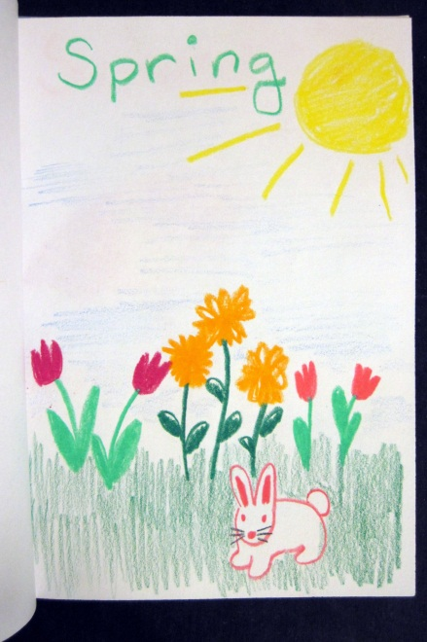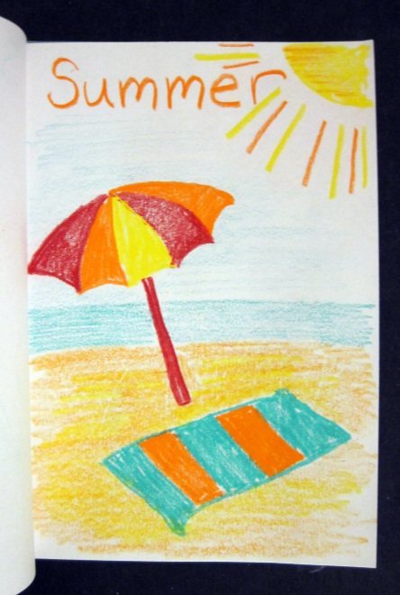 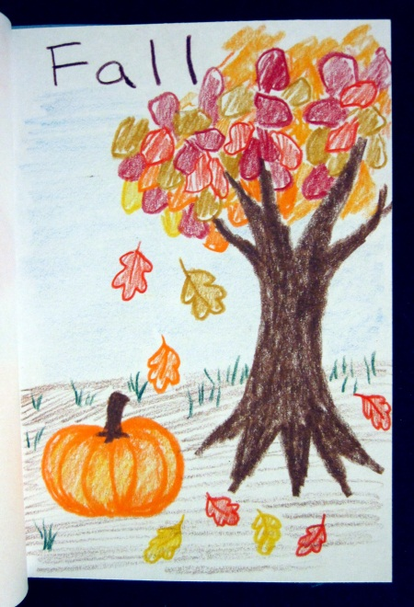

A. Where Art Classroom

B. Grade/Student Level Kindergarten

C. Class/Date/Times One-Two 50 minute periods

**II. CURRICULUM CONTENT:**

**Historical, Cultural and Social Contexts**

Students understand the impact of visual art on the history, culture and society from which it emanates.

They understand the cultural, social and political forces that, in turn, shape visual art communication and expression. Students identify the significant contributions of visual artists to cultural heritage. They analyze the historical, cultural, social and political contexts that influence the function and role of visual art in the lives of people.

**Benchmark C:** Identify and describe the different purposes people have for creating works of art.

**Kindergarten Grade Level Indicator:**

Recognize that people create works of art and art objects for different purposes.

**Creative Expression and Communication**

Students create artworks that demonstrate understanding of materials, processes, tools, media, techniques and available technology. They understand how to use art elements, principles and images to communicate their ideas in a variety of visual forms.

**Kindergarten Grade Level Indicators:**

1. Explore and experiment with a variety of art materials and tools for self-expression.

2. Identify and name materials used in visual art.

3. Explore art elements to express ideas in a variety of visual forms (e.g. drawings, paintings and ceramics).

4. Generate ideas and images for artwork based on memory, imagination and experience.

**Earth and Space Sciences**

|  |
| --- |
| Students demonstrate an understanding about how Earth systems and processes interact in the geosphere resulting in the habitability of Earth. This includes demonstrating an understanding of the composition of the Universe, the Solar System and Earth. In addition, it includes understanding the properties and the interconnected nature of Earth's systems, processes that shape Earth and Earth's history. Students also demonstrate an understanding of how the concepts and principles of energy, matter, motion and forces explain Earth systems, the Solar System, and the Universe. Finally, they grasp an understanding of the historical perspectives, scientific approaches and emerging scientific issues associated with Earth and space sciences. |

**Grade Level Indicators:**

1. Observe and describe day-to-day weather changes (e.g., today is hot, yesterday we had rain).

2. Observe and describe seasonal changes in weather.

1. **General Description**

Students will discuss different types of weather, then create a weather book of construction and sulfite paper that illustrates each different type.

1. **Cognitive Goals: (Bloom)**
2. Understand that weather can change from day to day
   1. Illustrate multiple types of weather
   2. Discuss daily weather changes with class
3. Understand the art element of color
   1. Use different colors that are suitable for depicting different types of weather (e.g. blue for rain and yellow for sun)
4. Understand bookmaking
   1. Create a book by folding paper
5. **Affective Goals: (Krathwohl)**
6. Follows directions well
   1. Cooperates with teacher’s instructions quickly
   2. Asks questions when necessary
   3. Completes task as instructed
7. Works independently
   1. Able to complete task without seeking excessive assistance
   2. Does not disrupt classmates with chatter or play
8. Works cooperatively
   1. Shares materials
   2. Shares space
9. **Psycho/Motor Skill Goals (Simpson)**
10. Color with magic markers
    1. Hold marker correctly (between forefinger and thumb rather than in fist)
    2. Color with marker so white paper does not show through
11. Fold paper in half to create book
    1. Line up corners of paper, then crease along edge to make fold
    2. Repeat with second piece of paper
12. Bind book
    1. Open pages and punch on hole on each side of seam by using hole punch
    2. Thread yarn through both holes and tie in bow on outside of spine (like tying shoes)
13. **Vocabulary: defined**

**Bookbinding:** The art of making a book by hand

**Weather:** The way it feels outside. Weather can be sunny, rainy, cold, hot, snowy, icy, windy, etc.

**Color**: An element of art, color is the way something looks based on how it reflects light. Colors include red, yellow, blue (primary colors), orange, purple, and green (secondary colors).

**Form**: The 3-D shape of something. By folding our flat paper, we can give it the form of a book.

1. **Materials/Tools: quantity and quality specified**

**Note: quantities based on a total of 45 students**

* 30 sheets 12” x 18” white sulfite paper, cut into 6” x 9” sections
* 12 sheets 12” x 18” construction paper (assorted colors) cut into 6” x 9” sections
  + One 6” x 9” piece per student
* 8 hole punches
* Assorted yarn
* Scissors for trimming yarn

1. **Teacher Resources**

* Teacher exemplar

­

1. **Bibliography**
   1. [www.odc.state.oh.us/curriculum-assessment/ci/](http://www.odc.state.oh.us/curriculum-assessment/ci/)
   2. [www. arteducators.org](http://www.arteducators.org)
   3. [www.oaea.org](http://www.oaea.org)
   4. <http://ohiorc.org/standards/ohio/grade/science/k.aspx>

**III. TEACHING STRATEGIES**

1. **Motivation:** (**Artistic**, Intellectual, Imaginative, Kinesthetic) describe

Kids will get to make their very own books!

1. **Methodology/Procedures (Hunter)**
2. Discussion of weather
   1. T has S brainstorm different types of weather
   2. T writes types of weather down in word document on projector
      1. Alternate possibility is newsprint pad/sharpie
   3. T asks S what colors they associate with each type of weather
   4. T asks S how each type of weather makes them feel
   5. T asks S different things that reminds them of that type of weather (i.e. umbrella, sled, etc.)
3. Demo of paper folding process
   1. T folds 2 pieces of pre-cut sulfite paper in half
      1. T lines up opposite edges of paper, then holds them down with non-dominant hand
      2. T uses dominant hand to press down and crease folded edge of paper with a sweeping motion
   2. T repeats folding process with construction paper cover
4. T has 2 S volunteers distribute paper
   1. One S distributes 2 sheets white to every S
   2. Other S volunteer distributes 1 sheet colored paper S
5. S fold paper as demoed
6. T demos drawing process
   1. T uses colors associated with weather from brainstorm and writes the name of a different type of weather in appropriate color at bottom of each page
   2. Above each word, T illustrates the type of weather, or some accoutrement of that type of weather (i.e. an umbrella for rain, sled for snow, etc.)
7. T distributes 1 cup markers per 4 S
8. S illustrate books as demoed
9. T demos binding book
   1. T opens book flat
   2. T uses hole punch to put on hole on top and bottom edge of center fold
      1. T emphasizes verbally the importance of keeping the hole right in the center
   3. T inserts pre-cut yarn through hole from outside to inside, then back out
   4. T ties loose ends of yarn snugly but not so tight the book bends, then ties in a bow like shoelaces
10. T has S volunteer distribute hole punches (one to every 2 S) and pre-cut yarn
11. S bind book as demoed by T
12. Clean-up

C. Discipline Model Description (Canter)

**IV. ASSESSMENT/EVALUATION:** critical analysis of observed results

**Observation Criteria:**

* Student is on-task and working
* Student does not distract others
* Student cooperates with partner during printing

**Oral Assessment:**

T quizzes S to name the seasons

T quizzes S on associative colors

T quizzes S on symbols for each season

**Rubric**:



**V. COMMENDATIONS AND RECOMMENDATIONS FOR FUTURE LESSONS**

* Stapling with miniature staplers proved impossible for little hands. I stapled for them, but for future purposes it would be best to find a way they can secure the book’s binding without assistance (e.g. a stapler designed for those with weaker hands, etc.)
* Similar book concept could be applied to other projects. Students could make their own sketch books, for instance.