**Lesson Plan/Format**

NAME Dina Hoeynck COURSE INSTRUCTOR

**I. PROJECT TITLE:**  Tunnel Books

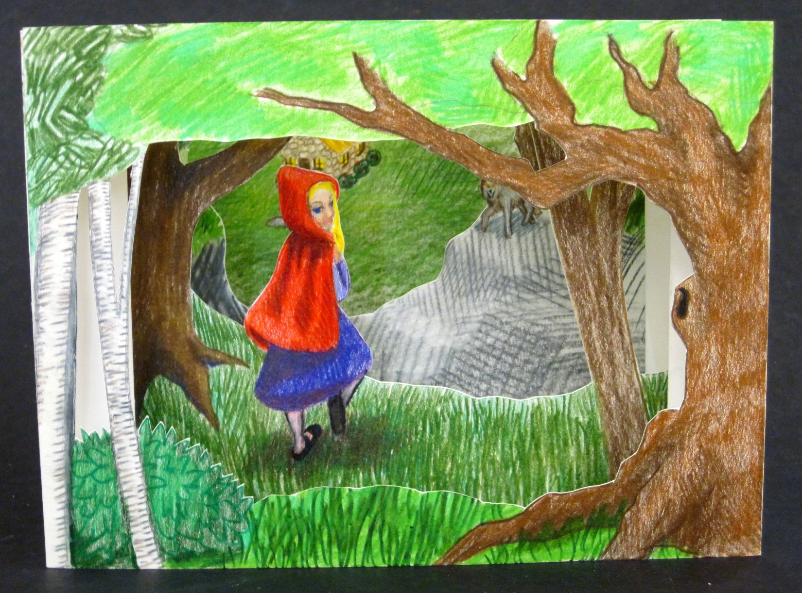

A. Where Art Classroom

B. Grade/Student Level 7th Grade

C. Class/Date/Times Three-Four 50 minute periods

D. Room Description

**II. CURRICULUM CONTENT:**

**Creative Expression and Communication**

Students create artworks that demonstrate understanding of materials, processes, tools, media, techniques and available technology. They understand how to use art elements, principles and images to communicate their ideas in a variety of visual forms.

**Grade Level Indicators:**

1. Demonstrate a variety of techniques to create the illusion of depth.
2. Apply observation skills to refine and improve their representational drawings (e.g., add details, improve proportion, create distinctive images and coordinate objects spatially).
3. **General Description**

Each student will create a tunnel book consisting of four panels that illustrate a commonly known story (e.g. a fairy tale, Shakespeare, etc.).

1. **Cognitive Goals: (Bloom)**
2. Clearly illustrates commonly known story
   1. Identifies iconic images that can be used to convey meaning
   2. Uses available resources (e.g. web, stock image books) to find drawing references
3. Understands element of space
   1. Creates deep space in tunnel book format
      1. Size of peephole decreases as panels move further back
      2. Size of subject decreases as panels move further back
4. Understands principle of proportion
   1. Size of peephole decreases as panels move further back
   2. Size of subject decreases as panels move further back
5. **Affective Goals: (Krathwohl)**
6. Follows directions well
   1. Cooperates with teacher’s instructions
   2. Asks questions when appropriate
   3. Completes task as instructed
7. Works independently
   1. Able to complete task without seeking excessive assistance
   2. Does not disrupt classmates with excessive conversation
8. Works cooperatively
   1. Shares materials when appropriate
   2. Shares workspace when appropriate
   3. Works cooperatively with other students
9. **Psycho/Motor Skill Goals (Simpson)**
10. Folds concertina for each side of tunnel book
    1. Uses smooth object (e.g. Sharpie marker) to crease folds
    2. Creates evenly spaced folds by following technique of folding in half, then in half again, etc.
    3. Creates two identical concertinas
11. Uses double stick tape to construct book
    1. Lays down double stick tape in correct location
    2. Settles each page fully into crease of concertina before adhering
12. Cuts windows in book panels using Xacto knife
    1. Cuts window accurately without torn edges
    2. Uses knife safely, never laying a finger or thumb in the path of the blade
13. **Vocabulary: defined**

* **Tunnel Book:** Named after commemorative books created for the opening of the tunnel under England’s Thames river, tunnel books (or peepshow books) consist of a series of panels with holes cuts in them to allow the viewer to see the panels behind.
* **Carol Barton:** A contemporary book artist who specializes in pop-ups and other unusual forms such as tunnel books
* **Space:** An element of art; in this context, the perception of things moving backward into the distance.
* **Proportion:** A principle of art; the relative size of two or more things.
* **Concertina:** In book arts, a piece of paper that has been folded in a zig-zag shape. Named after the instrument; also called an accordion fold.
* **Foreground:** The objects in a composition closest to the viewer.
* **Middle Ground:** The objects in a composition between the foreground and background.
* **Background:** The objects in a composition furthest from the viewer.
* **Valley fold:** A bookbinding term; a fold in a piece of paper creating a V shape
* **Mountain fold:** A bookbinding term; a fold in a piece of paper creating an upside-down V shape

1. **Materials/Tools: quantity and quality specified**

* One ream 8.5” x 11” cardstock, cut in half to 8.5” x 5.5”
* 20 #2 pencils with erasers
* Colored pencil classpack
* 20 Xacto knives
* 20 cutting mats
* Between one and three rolls of 3m 415 double stick adhesive (as budget permits)
* Several pairs of scissors (for cutting double stick adhesive)
* Pan watercolors and brushes (optional)

1. **Teacher Resources**

* ­powerpoint presentation
* Teacher exemplar

1. **Bibliography**
   1. [www.odc.state.oh.us/curriculum-assessment/ci/](http://www.odc.state.oh.us/curriculum-assessment/ci/)
   2. [www. arteducators.org](http://www.arteducators.org)
   3. [www.oaea.org](http://www.oaea.org)
   4. http://svmedaris.com/2010art/ma_show_pics/meat_locker_01_72.jpg
   5. http://tricotreat.wordpress.com/2011/06/26/tunnel-book/
   6. http://ingriddijkers.blogspot.com/2009/11/i-just-finished-up-this-color-version.html
   7. <http://chewybagelheadgremlin.blogspot.com/2011/03/cavity-tunnel-book.html>
   8. <http://andreadezso.com/BOOKS_Tunnel4.html>

**III. TEACHING STRATEGIES**

1. **Motivation:** (Artistic, Intellectual, Imaginative, Kinesthetic) describe
2. **Methodology/Procedures (Hunter)**
3. T introduces project
   1. T shows exemplar
   2. T shows powerpoint presentation of tunnel books
   3. T provides historic context for name
      1. Tunnel book named after commemorative book made for the opening of the tunnel under the Thames.
4. T brainstorms commonly known stories with S
   1. T writes these on a large piece of paper at front of room
   2. T asks S to each pick one story to illustrate
5. T explains construction of tunnel book
   1. T uses T exemplar to illustrate construction
   2. T walks S through creating concertina folds
      1. Fold paper in half, crease
      2. Fold free ends in toward center fold, crease again (three mountain folds)
      3. Create mountain folds again between each of the previous folds
      4. Create valley folds halfway between each mountain fold
      5. T demonstrates how to lay down double stick tape, create folds on sides of interior leaves
         1. Run double stick tape as close to edge of paper as possible, trimming with scissors before running off paper. Repeat on opposite side
         2. Mountain fold side of paper with tape just next to tape line. Repeat on other side.
6. T demos safety using an exacto knife
   1. T draws a sample circle to cut out of cardstock
   2. T lays cardstock on cutting mat
   3. T uncaps kife, places point at start of line at low angle to page
   4. T pulls knife slowly and deliberately through cardstock, turning page into curves
      1. T verbally reinforces to S that T is ensuring no fingers are in the path of the knife
7. S begin concept sketches
   1. T tasks S t each decide what they will draw, and sketch 4 panels
   2. S put names on these, turn in for approval

***************DAY TWO***************

1. T demos working with colored pencil on ELMO
   1. T demos varying pressure to change values
   2. T demos blending with a complement to create shadows
   3. T demos blending with white to create tints
2. T returns concept sketches with feedback
3. T has S volunteers distribute cardstock
4. S begin final drawings
   1. S sketch drawing lightly in pencil
   2. S color over drawing using colored pencil, erasing graphite as they draw
   3. S vary pressure of colored pencil to create changes in value
   4. S layer colored pencil with complementary colors to create shadows
   5. S layer colored pencil with white to create tints

***************DAY THREE***************

1. T demos book assembly
   1. T cuts windows on book
   2. T applies tape to back panel, adheres to back concertina folds one at a time
   3. T removes adhesive protector from one side of next panel, places in concertina fold and presses
      1. T repeats for other side of panel
      2. T repeats for from two panels
2. S finish colored pencil drawings
3. S cut windows as demoed by T
4. S construct book as demoed by T

C. Discipline Model Description (Canter)

**IV. ASSESSMENT/EVALUATION:** critical analysis of observed results

**Behavioral Checklist:**

* Student uses all materials safely
* Student uses time effectively
* Student does not distract others

**Quiz:**

Define in a sentence the following terms:

Foreground:

Background:

Proportion:

Bonus: Who is Carol Barton?



**V. COMMENDATIONS AND RECOMMENDATIONS FOR FUTURE LESSONS**