NAME Dina Hoeynck COURSE INSTRUCTOR

**I. PROJECT TITLE:**  Putting Yourself in Perspective

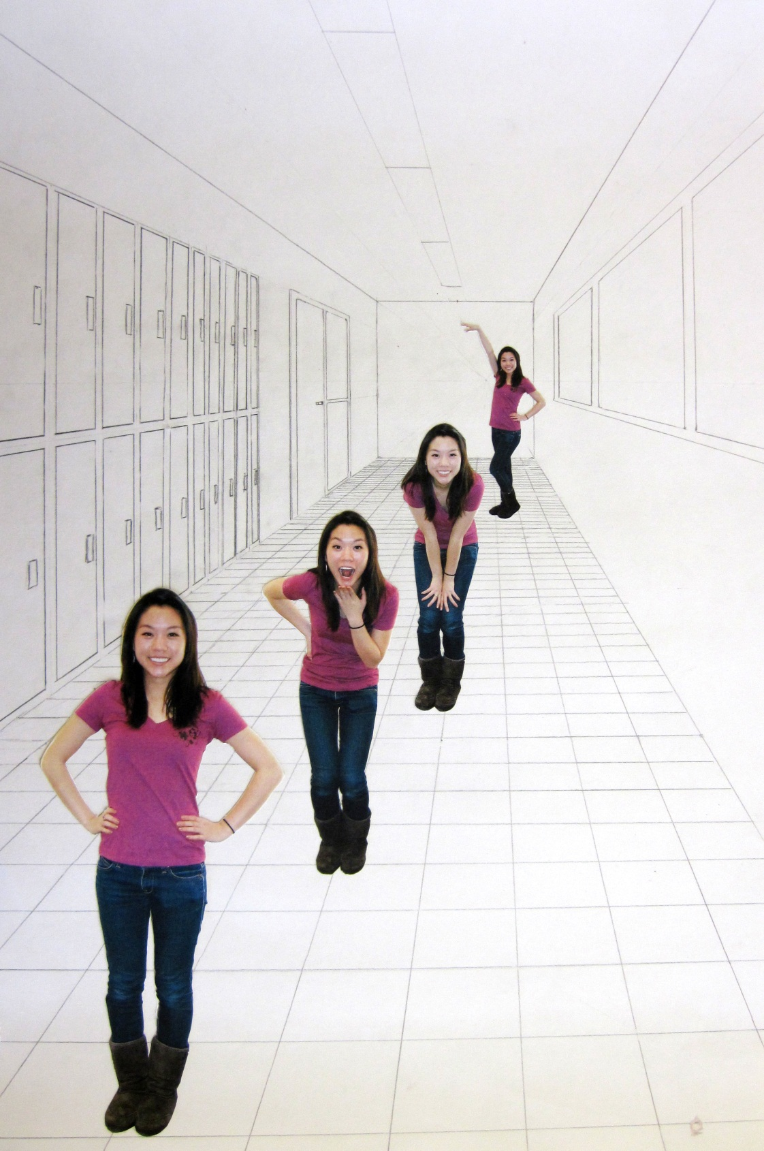

A. Where Art Classroom

B. Grade/Student Level 7th Grade

C. Class/Date/Times Three 50 minute periods

D. Room Description

**II. CURRICULUM CONTENT:**

**Creative Expression and Communication**

Students create artworks that demonstrate understanding of materials, processes, tools, media, techniques and available technology. They understand how to use art elements, principles and images to communicate their ideas in a variety of visual forms.

**Grade Level Indicators:**

1. Demonstrate a variety of techniques to create the illusion of depth.
2. Apply observation skills to refine and improve their representational drawings (e.g., add details, improve proportion, create distinctive images and coordinate objects spatially).
3. Use current, available technology as the primary medium to create an original work of art.
4. **General Description**

Students will learn how to create a drawing using single point perspective. They will create original drawings using single point perspective, then use a digital camera and Adobe Photoshop Elements to insert four different photos of themselves in different scale into the drawing.

1. **Cognitive Goals: (Bloom)**
2. Understand the art principle of proportion
   1. Create a proportionate series of photos of themselves receding in space
3. Understand the art element of space
   1. Create space using single point perspective
   2. Identify linear perspective vocabulary terms in a written quiz
4. Integrate digital technology into a finished work of art
   1. Take digital photos of a classmate
   2. Manipulate digital photos in Photoshop
   3. Incorporate digital photos in a drawing
5. **Affective Goals: (Krathwohl)**
6. Follows directions well
   1. Cooperates with teacher’s instructions
   2. Asks questions when appropriate
   3. Completes task as instructed
7. Works independently
   1. Able to complete task without seeking excessive assistance
   2. Does not disrupt classmates with excessive conversation
8. Works cooperatively
   1. Shares materials when appropriate
   2. Shares workspace when appropriate
   3. Works cooperatively with other students to use digital camera
9. **Psycho/Motor Skill Goals (Simpson)**
10. Draws controlled lines using a ruler
11. Accurately erases the background from a photograph using the magic wand and polygonal lasso tools in Photoshop Elements.
    1. Does not erase visibly into the figure
    2. Does not leave any visible background
12. **Vocabulary: defined**

**Linear Perspective:** A technique used by artists since the Renaissance for creating the illusion of depth.

**Single Point Perspective:** A linear perspective strategy with only one vanishing point.

**Orthogonal Line:** In linear perspective, orthogonals are those lines which converge at the vanishing

point.

**Vanishing Point:** The point on the horizon line at which all orthogonal line converge.

**Horizon Line:** The imaginary line at which the ground meets the sky.

**Proportion:** The size relationships of two or more objects in a work of art.

1. **Materials/Tools: quantity and quality specified**

* 20 sheets white sulfite paper, 18” x 24”
* 30 #2 pencils
* 20 pink pearl erasers
* 20 glue sticks
* Computers equipped with Adobe Photoshop Elements
* Color Printer
* Digital Camera (to be shared)
* Card reader (to be shared)

1. **Teacher Resources**

* Art historical PowerPoint slideshow of Renaissance examples of single point perspective
* teacher exemplar

­

1. **Bibliography**
   1. [www.odc.state.oh.us/curriculum-assessment/ci/](http://www.odc.state.oh.us/curriculum-assessment/ci/)
   2. [www. arteducators.org](http://www.arteducators.org)
   3. [www.oaea.org](http://www.oaea.org)
   4. <http://www.dawnsbrain.com/?p=34>
   5. artchive.com

**III. TEACHING STRATEGIES**

1. **Motivation:** (Artistic, Intellectual, Imaginative, **Kinesthetic**) describe

Students will have fun posing for goofy photos with their classmates.

1. **Methodology/Procedures (Hunter)**
2. T introduces concepts of perspective
   1. T shows art historical examples of linear perspective
      1. T explains that perspective was developed during the Renaissance
      2. T contrasts renaissance artist’s application of mathematical principles against the medieval art that preceded it.
      3. T identifies on examples the location of horizon line, vanishing point, and orthogonal lines.
      4. T emphasizes that vertical lines will always be perfectly vertical, while horizontal lines can be either perfectly horizontal (as in one point perspective) or orthogonal (as in two point perspective).
3. T introduces perspective worksheet and demonstrates steps on ELMO
   1. T demonstrates how to use ruler as a square to ensure that verticals and horizontals are accurate.
      1. T lines short edge of ruler up with edge of paper.
   2. T demonstrates each step on worksheet, as illustrated on worksheet.
   3. T draws lightly with pencil, verbally emphasizing to draw lightly for easy erasures.
4. T distributes perspective worksheet and S complete it.
5. T grades worksheets after class and gives written corrections and feedback.

**************DAY TWO**************

1. T distributes bell quiz.
   1. S complete bell quiz.
   2. T collects bell quiz.
2. T shows exemplar and explains that they will be using their knowledge of perspective drawing to create an original composition, then using photoshop elements to insert pictures of themselves in the work.
3. T introduces terms proportion and scale in reference to the photos.
4. T returns worksheets from previous day with feedback for improvement.
5. T distributes materials for drawing, and asks S to each choose a partner.
   1. T distributes paper, pencils, and pre-printed guides on drawing in perspective (beginner, intermediate, and advanced)
6. S begin drawings
   1. All lines are made using ruler and pencil
   2. S begin by drawing horizon and identifying a vanishing point.
   3. S refer to pre-printed guides on drawing in perspective (beginner, intermediate, and advanced) to assist in creating accurate perspective drawings
7. S take photographs
   1. While S work, T pulls S out two at a time and has each S photograph the other in five different poses against a blank wall.
   2. T then uploads S photographs to first computer.
   3. T picks next 2 students.
   4. S photograph each other.
   5. T uploads S photos to next computer.
   6. Repeat steps 5.4 and 5.6 until entire class has photos on computer.
8. T demonstrates photo editing process.
   1. In finder, T navigates to the desktop and creates a new folder.
   2. T names the folder name_class
   3. T opens photos in Photoshop Elements
   4. If necessary, T rotates each photo by going to Image🡪Rotate and selecting either 90 degrees left or 90 degrees right (whichever your image requires).
   5. T crops photo to include only body by using the crop tool (10th down on the left). T clicks and drags a box around body, then presses ENTER to crop.
   6. T fixes the brightness and contrast by going to Enhance🡪 Adjust Lighting🡪 Brightness/Contrast. T adjusts these sliders so image looks well-lit and has a full range of white, black, and in-between values.
   7. Using the Magic Wand Tool (7th tool down on the left) T clicks on background of photo to select it. Holding shift while clicking will allow you to add to selection. T demonstrates that if S accidentally selects too much, to go to Edit🡪Deselect (keyboard shortcut Command + D).
   8. When the entire background is selected (but none of body) T presses the DELETE key.
   9. The polygonal lasso tool can also be used instead of the magic wand for more control. This tool is 6th down on the right. T clicks and holds the lasso tool; underneath it are the magnetic and polygonal lasso tools.
   10. To use the polygonal lasso tool, T carefully clicks around the outline of the person
   11. When T traces entire body, T hits the ENTER key.
   12. Now object is selected. T selects the background by hitting Select🡪Inverse.
   13. As before, once the background is selected, T hits the DELETE key.
   14. T goes to to Image🡪Resize🡪Image Size.
       1. T instructs that each S photo should be a different size, and all of them should be 300 DPI.
   15. T clicks file🡪new and creates a canvas that is 8.25” x 10.75” and 300 dpi
   16. T returns to first image and hits COMMAND + A to select the entire image.
   17. T hits COMMAND + C to copy the image.
   18. T clicks on the new file, and hits COMMAND + V to paste the image.
   19. T uses the move tool (1st tool on the left) to position the photo on the new page.
   20. T explains that S will repeat previous 4 steps for each of the remaining 3 photos so they are all on the same page with no overlap.
   21. T clicks file🡪save and saves finished page layout to the desktop in previously created folder. Explains to title it “name_class_perspective” (e.g. Annie_214_perspective)
   22. T clicks File🡪Print.

**************DAY THREE**************

1. S continue to work on drawings while waiting to edit photos.
2. When photos are printed, S cut carefully around each photo using scissors
3. T demonstrates how to cut photos
   1. Using scissors, make short rhythmic cuts while turning the paper into the blades.
   2. Using a knife
      1. place a cutting mat on the table
      2. lay printout on cutting mat
      3. keep a shallow angle with knife and press with only moderate pressure while cutting towards self
      4. ensure fingers are not in the path of knife while cutting
4. T demonstrates gluing
   1. Lay photo face down on piece of scrap paper
   2. start glue stick in center of photo and pull outward over all edges of picture until entire back is coated with a thin layer of glue
   3. lay in place then lay a clean piece of scrap paper over back of photo
   4. use side of hand to press and rub into place
5. S repeat cutting and gluing processes to complete their drawings.
6. S glue each photo in the appropriate place on the project., following the laws of perspective and using reference objects within the composition (e.g. a girl should not be taller than a locker)
7. Clean-up involves discarding any scrap pieces of paper and cleaning glue off of all surfaces.

C. Discipline Model Description (Canter)

**IV. ASSESSMENT/EVALUATION:** critical analysis of observed results

Name:

Homeroom #:

**Perspective Quiz**

Using a ruler and pencil, draw a room in one point perspective. Please include a door and window, but **do not** tile the floor: **10 pts.**

When you have finished your drawing, use the appropriate colored pencil to highlight one example of each of the following terms: **2 pts. each**

Horizon Line Orthogonal Line Vertical Line Horizontal Line Vanishing Point

(purple) (blue) (green) (orange) (red)

Name: Class:

**Put a checkmark next to each step as you complete it.**

1. Click on the blue background of the desktop.
2. At the top of the screen, click file🡪new folder.
3. Name your new folder with your name and class #
4. Open the folder on the desktop labeled “Day (your day) perspective photos”
5. Find your pictures, and drag all of them into the folder you just created.
6. Launch Photoshop Elements (the blue square labeled PSE)
7. At the top of Photoshop, click File🡪New🡪Blank File. Set the size of your file to 8.25” x 10.75” and 300 pixels/inch.
8. Go to File🡪Open and open up your photos.
9. Crop your first photo to include only your body by using the crop tool (10th down on the left). Click and drag a box around yourself, then press ENTER to crop.
10. Fix the brightness and contrast by going to Enhance🡪 Adjust Lighting🡪 Brightness/Contrast. Adjust these sliders so your image looks well-lit and has a full range of white, black, and in-between values.
11. Hit COMMAND + A to select the entire image.
12. Hit COMMAND + C to copy the image.
13. Click back to the blank file, and hit COMMAND + V to paste the image.
14. Click on the move tool (1st tool on the left). You can now reposition the photo by clicking and dragging it, and resize it by clicking one of the corner boxes and dragging it in or out.
15. Repeat steps 9-13 for each of the remaining photos so they are all on the same page with no overlap. Each photo should be a noticeably different size.
16. Click file🡪save and save your finished page layout to the desktop in your folder. Title it “name_class_perspective” (e.g. Annie_214_perspective)
17. Finally, click File🡪Print.



**V. COMMENDATIONS AND RECOMMENDATIONS FOR FUTURE LESSONS**

Possible extensions of lesson:

Add shadows to drawing

Add images in perspective using skew tool in photoshop to create an “art gallery”

Add reflection to image (see student exemplar)