**Lesson Plan/Format**

NAME Dina Hoeynck COURSE INSTRUCTOR

**I. PROJECT TITLE:**  Felt Luchador Masks

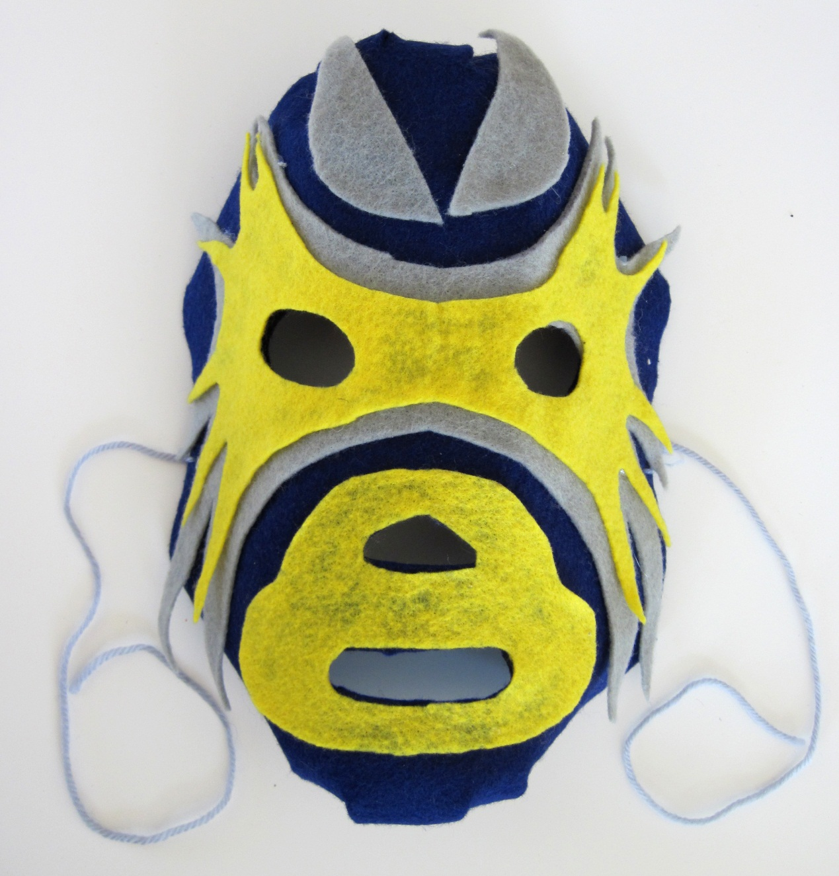

A. Where Art Classroom

B. Grade/Student Level 3rd/4th Grade

C. Class/Date/Times Two 50 minute periods

D. Room Description

**II. CURRICULUM CONTENT:**

**Creative Expression and Communication**

Students create artworks that demonstrate understanding of materials, processes, tools, media, techniques and available technology. They understand how to use art elements, principles and images to communicate their ideas in a variety of visual forms.

**3rd Grade Level Indicators:**

1. Demonstrate skill and expression in the use of art techniques and processes.
2. Use appropriate visual art vocabulary when describing art-making processes.
3. Recognize and identify a purpose or intent for creating an original work of art.
4. Identify relationships between selected art elements and principles (e.g., color and rhythm).

**4th Grade Level Indicators:**

1. Discuss their artworks in terms of line, shape, color, texture and composition.
2. Initiate and use strategies to solve visual problems (e.g., construct three dimensional art objects that have structural integrity and a sense of completeness).
3. **General Description**

Teacher will expose students to images of luchador masks, and discuss their role in Mexican culture. Then, students will select three contrasting colors of felt and make their own luchador masks. The project will explore the elements of shape and color and the principles of contrast and balance (through symmetry).

1. **Cognitive Goals: (Bloom)**
2. Understand element of shape
   1. Create organic or geometric shapes out of felt
   2. Verbally identify shapes as organic or geometric.
3. Understand element of color
   1. Understand that every color has a value
   2. Understand that every color has a hue
   3. Identify contrasting hues
4. Understand principle of contrast
   1. Create contrast in felt mask by using colors with contrasting hues
   2. Create contrast in felt mask by using colors with contrasting values
5. Understand principle of balance
   1. Create balance in mask by using symmetry
6. **Affective Goals: (Krathwohl)**
7. Follows directions well
   1. Cooperates with teacher’s instructions quickly
   2. Asks questions when necessary
   3. Completes task as instructed
8. Works independently
   1. Able to complete task without seeking excessive assistance
   2. Does not disrupt classmates with chatter or play
9. Works cooperatively
   1. Shares materials
   2. Shares space
10. **Psycho/Motor Skill Goals (Simpson)**
11. Cuts shapes for felt mask
    1. Folds felt in half along line of symmetry before cutting to create symmetrical shapes
    2. Cuts through two piece of felt at once to create identical shapes
    3. Cuts smoothly without making rough, wiggly, or jagged edges
12. Uses hot glue to construct mask
    1. Under teacher supervision, applies a steady strand of hot glue to each loose piece before adhering to base of mask
    2. Uses enough hot glue to securely attach all pieces but not so much it spills or shows
13. Turns 2-D mask into 3-D mask
    1. Traces template and cuts slits
    2. Overlaps flaps of felt and staples together securely
14. **Vocabulary: defined**

**Complementary Colors**: Colors that are across from each other on the color wheel

**Hue**: What we think of as color (e.g. blue or red)

**Value**: The lightness or darkness of a color

**Contrast**: a principle of art. Contrast exists when two visual components that are very different from each other are placed side by side.

**Symmetry:** Symmetrical images are the same in multiple directions.

**Mirror Symmetry**: Images with mirror symmetry are identical on their left and right sides, as if reflected in a mirror.

**Line of symmetry**: the imaginary line in which two sides of a symmetrical image meet.

1. **Materials/Tools: quantity and quality specified**

**Note: materials listed for 80 students, 4 classes of 20**

* 160 sheets 9” x 12” felt, assorted colors
* Two low-temperature hot glue guns
* Large bag 10” dual temp hot glue sticks
* 20 pairs scissors
* 3 rolls masking tape (for labeling in-progress work)
* 20 Sharpie Markers (for labeling in-progress work)
* One or two skeins of colored yarn, for tying strings onto masks
* A good stapler

1. **Teacher Resources**

* Color Wheel Poster
* Slideshow of lucha libre masks and fighters
* Templates for mask construction (6 templates total)
* Teacher Exemplar

1. **Bibliography**
   1. [www.odc.state.oh.us/curriculum-assessment/ci/](http://www.odc.state.oh.us/curriculum-assessment/ci/)
   2. [www. arteducators.org](http://www.arteducators.org)
   3. [www.oaea.org](http://www.oaea.org)

**III. TEACHING STRATEGIES**

1. **Motivation:** (Artistic, Intellectual, **Imaginative**, Kinesthetic) describe

Students will get to imagine that they are Mexican wrestlers and develop their own personae and wrestler names.

1. **Methodology/Procedures (Hunter)**
2. T prep:
   1. Cut 1/3 of felt sheets in half
   2. Lay small stack (5 sheets) of each color felt out on counter.
   3. Set up powerpoint
   4. Set aside color wheel poster
3. T introduces project
   1. T asks “who has heard of lucha libre?”
      1. S answer
   2. T tells S that each luchador has his own persona, and he gets into character by putting on his mask. His mask lets his fans see him from all the way in the back of the stands because it has simple shapes and high contrast.
   3. T shows slides of luchador masks
      1. T defines contrast as the difference between two things.
      2. T explains that colors have value and hue.
         1. Hue is what we think of as color (blue, red, etc.)
         2. Value is lightness or darkness
         3. Two colors can create contrast because they have very different values or very different hues (eg complementary colors)
      3. T shows color wheel
         1. T points to Yellow and asks S to pick complementary color.
   4. End slideshow, return S to seats
4. T introduces felt selection process
5. T tells S they will be called table by table (based on behavior) to select felt
   1. T tells S they must select one full sheet, and that this will be the main color of their mask
   2. Then they will select two half sheets, and these will be the accent colors.
   3. T reminds S that at least two of their colors should contrast in value, hue, or both.
6. T call S one table at a time to select felt, telling them to line up single file.
   1. Each S selects one full sheet and two accent sheets, then returns to seat promptly
7. T demonstrates how to make basic face shape
   1. T demonstrates making eye holes
      1. T place sheet of felt over face
      2. T uses fingertips to gently feel where eyes are
      3. T pinches felt where eyes go
      4. T uses scissors to cut where pinch marks are
   2. T demonstrates cutting nose and mouth
      1. T repeats eyehole procedure for nose and mouth
   3. T demonstrates rounding corners
      1. T folds mask in half along line of symmetry
      2. T uses scissors to round corners
8. T demonstrates making decorations
   1. T explains that same process can be used for making decorations—fold in half and cut along line of symmetry.
   2. T shows how to cut holes in accent pieces by tracing through original mask’s holes with marker
9. S cut holes for eyes, nose and mouth and round corners as demonstrated by T
10. S cut decorations for felt mask as demonstrated by T
11. S clean up
    1. S roll small pieces of felt in large piece
    2. S wrap roll with single piece of masking tape
    3. S write name and class number on tape in marker

*********************DAY TWO*********************

1. T prep:
   1. T plugs in hot glue guns 5 minutes before class
2. T demos hot glue process on T exemplar
   1. T lays a thin line of glue on accent piece
   2. T lays accent piece in place and carefully presses down
   3. T emphasizes verbally that hot glue is extremely hot and to be very, very careful not to touch the glue or the metal tip of the gun.
   4. T also emphasizes that if anyone uses the hot glue without first seeking permission from T, they will be in big trouble!
3. T demonstrates process for turning flat mask into 3-d mask
   1. T traces around template onto back of mask
   2. T makes slits in top and bottom of mask according to template
   3. T overlaps resulting flaps and staples through all layers of felt
4. S complete masks
   1. T asks S to raise their hands as they complete their designs
   2. T calls S one at a time to glue masks together
   3. Once glued, S use scissors to cut flaps in mask and have T staple them together.
5. S select yarn for their masks, and T assists with stringing

C. Discipline Model Description (Canter)

**IV. ASSESSMENT/EVALUATION:** critical analysis of observed results

**Observational checklist:**

* Working intently with minimal conversation
* Stays in seat unless given permission to get up
* Creates mask using demonstrated procedures

**Exit Card:**

Give an example of two colors with contrasting Hue:

Give an example of two colors with contrasting Value:



**V. COMMENDATIONS AND RECOMMENDATIONS FOR FUTURE LESSONS**

* amend slideshow to show high contrast color relationships vs low-contrast color relationships overlapping to demonstrate greater legibility of high contrast (vs just showing complementary color dots around color wheel as previously)
* encourage S to overlap contrasting colors of felt within mask for greater visual impact