Lesson Plan/Format

NAME Dina Hoeynck COURSE INSTRUCTOR

I. PROJECT TITLE: Persian Miniatures

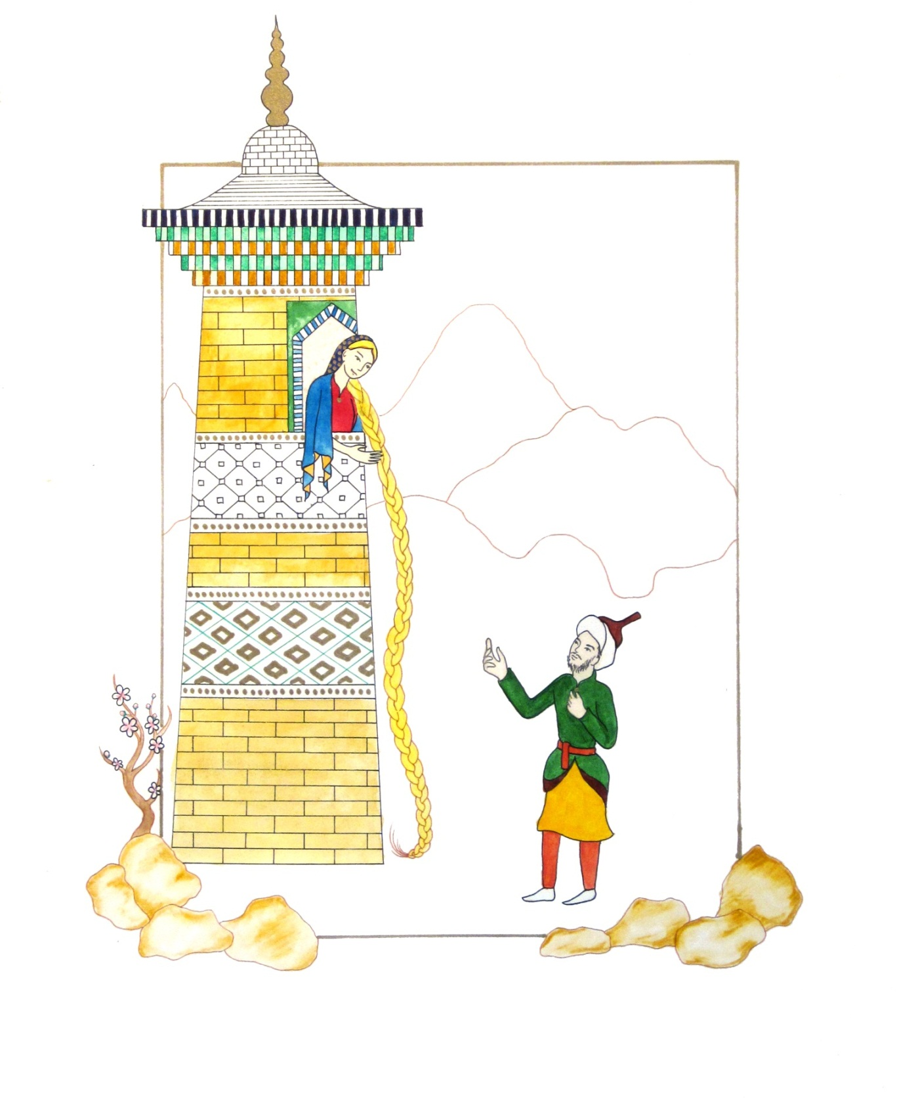

A. Where Art Classroom

B. Grade/Student Level 10th grade/ Art II

C. Class/Date/Times Four 50 minute class periods

D. Room Description

II. CURRICULUM CONTENT:

Creative Expression and Communication
Students create artworks that demonstrate understanding of materials, processes, tools, media, techniques and available technology. They understand how to use art elements, principles and images to communicate their ideas in a variety of visual forms.

Grade Level Indicators:

1. Trace the origin of symbolism, imagery and metaphor in art and demonstrate the use of these visual devices in their artworks.

2. Evaluate their choices of compositional elements in terms of how those choices affect the subject matter of the work.

- General Description

Following an art history lesson in which students are exposed to Iranian art, the class will create their own Persian Miniatures. They will choose an existing story, such as a fairy tale, and illustrate it in the style of a Persian Miniature using fine-tip markers, watercolors, and gold paint.

- Cognitive Goals: (Bloom)

- Understand element of shape
  - Use shape to create stylized figures in the manner of Persian miniatures

- Understand principle of pattern
  - Use pattern to adorn their pictures in the manner of Persian miniatures

- Understand the style of Persian Miniatures
  - Use isometric space
  - Use pattern
  - Use stylized figures
    - Figures shown in ¾ view
    - Figures have simplified facial features
  - Use vivid colors

- Affective Goals: (Krathwohl)

- Demonstrate pride and respect for own creative endeavors
  - Work with care and attention to detail
  - Treat work-in-progress and finished work with care

- Work neatly and cooperatively
  - Clean up after self
  - Share supplies
  - Share workspace

- Work independently
  - Complete all aspects of project without outside pressure
  - Practice skills needed to succeed in project

- Psycho/Motor Skill Goals (Simpson)

- Create decorative patterns in the style of Persian miniatures
  - Lightly draw patterns using a very sharp, hard (2H) pencil and ruler
  - Carefully trace patterns using ruler and fine-tip Sharpie
  - Let Sharpie dry
  - Erase underlying pencil marks by rubbing back and forth rapidly and lightly with soft kneaded eraser

- Draw outlines of figures using fine point pens
  - Sketch figures lightly with a sharp, hard (2H) pencil
  - Solidify outlines with pencil
  - Trace carefully over pencil outlines in a fluid motion without stopping
    - Lift pen off paper as line is finished to avoid leaving a dot at the end of the line
  - Erase underlying pencil marks by rubbing back and forth rapidly and lightly with soft kneaded eraser

- Paint with pan watercolors
  - Select appropriate brush size for area to be painted (large brush for large areas, small brush for areas of fine detail)
  - Wet brush
  - Swirl brush in color, rinsing thoroughly before changing colors
  - Blend multiple colors in lid of watercolor tray
  - Apply color to paper in translucent layers to achieve desired intensity

- Vocabulary: defined

Persian Miniature: A small painting on paper characterized by flat, vibrant areas of color,
stylized forms, flat areas of decorative pattern, and isometric perspective. Persian
miniatures typically illustrate a well-known story.
Shape: An element of art. An enclosed space, the boundaries of which are defined by other
elements of art (i.e.: lines, colors, values, textures, etc.). Shapes in Persian Miniatures are
typically clean-edged and stylized.
Stylized: Representations that are simplified from the way they would appear in the real world.
Pattern: A principle of art; decorative design created through repetition of a single design unit.
Isometric Perspective: Traditional Persian painting uses non-linear or “isometric” perspective,
meaning that all objects and figures are two-dimensional. All measurements are to scale,
no matter how far or close they are in distance.⁵
Gilding: The application of gold leaf to paper using sizing or glue

- Materials/Tools: quantity and quality specified

- 20 sheets 11” x 14” Bristol Board
- 40 sheets 8.5” x 11” white sulfite paper (for thumbnails)
- 20 2H pencils
- 20 kneaded erasers
- 20 sets pan watercolors
- 20 black ultra fine point sharpies or other permanent markers
- 20 brown ultra fine point sharpies or other permanent markers
- 20 green ultra fine point sharpies or other permanent markers
- 5 sets prismacolor markers
- 5 fine tip gold paint pens

- Classroom Resources
  - Powerpoint slideshow of Persian Miniature paintings*
  - Digital projector or smart board*
  - Laptop or other computer for running slideshow*
  - Student-accessible computers for finding source images
  - Student-accessible printer for printing source images
  - Teacher exemplar (see page one)

*from preceding art history lesson on Iran

- Bibliography
  - www.odc.state.oh.us/curriculum-assessment/ci/
  - www. arteducators.org
  - www.oaea.org
  - www.artstor.org
  - http://www.teachmideast.org/activities/45-culture/105-personal-miniature-paintings-activity
  - http://socialscience.tjc.edu/mkho/MEOC/Newletters/muslim_life_in_miniature.htm
  - http://www.davidmus.dk/en/collections/islamic/materials/miniatures
  - The Grammar of Ornament. Jones, Owen. 1809.

III. TEACHING STRATEGIES
- Motivation: (Artistic, Intellectual, Imaginative, Kinesthetic) describe

Students will create a beautifully ornamented, colorful painting. Best of all, they’ll get to adorn it with metallic gold paint pens.

- Methodology/Procedures (Hunter)

- T introduces Persian miniatures, referring back to previous lesson’s art historical PowerPoint.
  - T guides S through visual characteristics of Persian miniatures using visual examples
    - T explains isometric perspective
      - All objects are the same size no matter how far back they are.
      - Distance is indicated by height on the page
    - T describes pattern
      - T asks S where they see pattern on the page
      - T explains how the use of pattern contributes to the flat, graphic quality of the work.
    - T describes figures
      - T asks S whether the figures are realistic, and why or why not?
      - T explains they are stylized, meaning they are slightly exaggerated or simplified from real life. Similarly, the cherry blossoms are stylized, perfectly symmetrical five-petaled flowers. T contrasts this with naturalism.
    - T analyzes color with S
      - T asks S to describe the colors they see—are they bright or dull?
      - T explains that part of what makes Persian miniatures so fun to look at are the intense, vibrant colors used in them.
    - T discusses use of border
      - T explains that the border could be illuminated with elaborate patterns, but that they would be drawing a simple gold border that will serve as the “framing edge” for the composition.
      - T shows where the border has been broken by design elements, and specifies that S drawings should break the border on at least 2 edges.
  - T discusses the idea that Persian miniatures were used to illustrate stories.
    - T relates to commonly known stories in today’s culture
    - T asks S to brainstorm some stories they all would know, such as fairy tales
      - T writes down list of stories as student come up with them.
- T asks S to each pick a story and produce 3 thumbnail sketches of ideas for compositions
  - T distributes pencils, erasers, and paper
  - S allowed to use internet for reference images
  - T circulates throughout room while students sketch, reminding them to use isometric space.

********************DAY TWO********************

- T demonstrates how to draw a border 2.5” into the page
  - T measures 2.5” in on first edge and marks with a hard (2H) pencil.
  - T repeats on other side of this edge
  - T repeats all the way around, putting two tick marks on each edge
    - T connects tick marks using pencil and ruler.
- T demonstrates the first steps of drawing
  - Using hard (2H) pencil, T lightly sketches the figures
  - T then firms up this drawing with more prominent lines
  - T uses kneaded eraser to make any necessary erasures
    - T warms up kneaded eraser by twisting it between fingers
    - T erases with rapid, light movements
- T distributes paper to S and S begin drawing.
  - S write name on back of paper
  - S draw design from favorite thumbnail
    - S sketch design lightly with a sharp, hard (2H) pencil
    - S solidify outlines with pencil
  - S add pattern
    - Lightly draw patterns using a very sharp, hard (2H) pencil and ruler

********************DAY THREE********************

- T demonstrates tracing with markers
  - T draws with a fluid motion, lifting the pen at the end of the line so it will not leave a blot.
  - T discusses the use of different colored markers
    - Black creates a strong, graphic outline, while brown or green creates a softer, more painterly quality
    - Black creates greater contrast and draws the eye—good for focal points.
- S trace pencil outlines and patterns in fine tip permanent marker
  - S trace carefully over pencil outlines in a fluid motion without stopping
  - S lift pen off paper as line is finished to avoid leaving a dot at the end of the line
- T demonstrates erasing underlying drawing
  - T emphasizes that S must wait for ink to dry first
  - T reminds S to make sure they’ve traced everything they need to before erasing
  - T warms eraser by kneading it in hand
  - T uses kneaded eraser to remove pencil marks by rubbing briskly and lightly back and forth across the paper
    - T emphasizes not to use too much pressure or you can tear the paper
- T demonstrates coloring drawing
  - T demonstrates using watercolor
    - Watercolor is used for large areas of the illustration, harder to control in small dots because it bleeds
    - T demonstrates wet paper technique
      - With a wet brush and no pigment, T wets a selected area of image
      - Quickly, while paper is still wet, T swirls large wet brush in pigment and spreads it on one edge of wet area of paper
      - T shows class how color bleeds across the wet area without getting in the dry paper surrounding it.
  - T demonstrates using markers
    - T uses prismacolor markers to color in small dots of pattern.
  - T demonstrates gold paint pen.
    - T shakes pen before removing cap.
    - T presses tip of pen on piece of scrap paper to get paint flowing
    - T uses pen to create dotted pattern over colored area of image
    - T uses pen and ruler to create outline around image
      - T lays ruler just inside outline
      - T draws with paint pen, lifting up where image breaks the framing edge
      - T wipes ruler with paper towel before laying down again (as paint may transfer)
- S Erase underlying pencil marks by rubbing back and forth rapidly and lightly with soft kneaded eraser
- S add color to image using techniques demonstrated by teacher.
  - S use watercolor
    - S color larger areas of image with watercolor
    - S use wet paper technique
      - With a wet brush and no pigment, S wet a selected area of image
      - Quickly, while paper is still wet, S swirl large wet brush in pigment and spread it on one edge of wet area of paper
  - T use prismacolor markers to color in small dots of pattern.
  - S use gold paint pen
    - S shake pen before removing cap.
    - S press tip of pen on piece of scrap paper to get paint flowing, if necessary
    - S use pen to create dotted pattern over colored area of image
    - S use pen and ruler to create outline around image
      - S lay ruler just inside outline
      - S draw with paint pen, lifting up where image breaks the framing edge
      - S wipe ruler with paper towel before laying down again (as paint may transfer)

********************DAY FOUR********************

- S finish drawings, continuing work from previous day
- S sign drawings, clean up.

