**Lesson Plan/Format**

NAME Dina Hoeynck COURSE INSTRUCTOR

**I. PROJECT TITLE:**  Kandinsky Concentric Circles

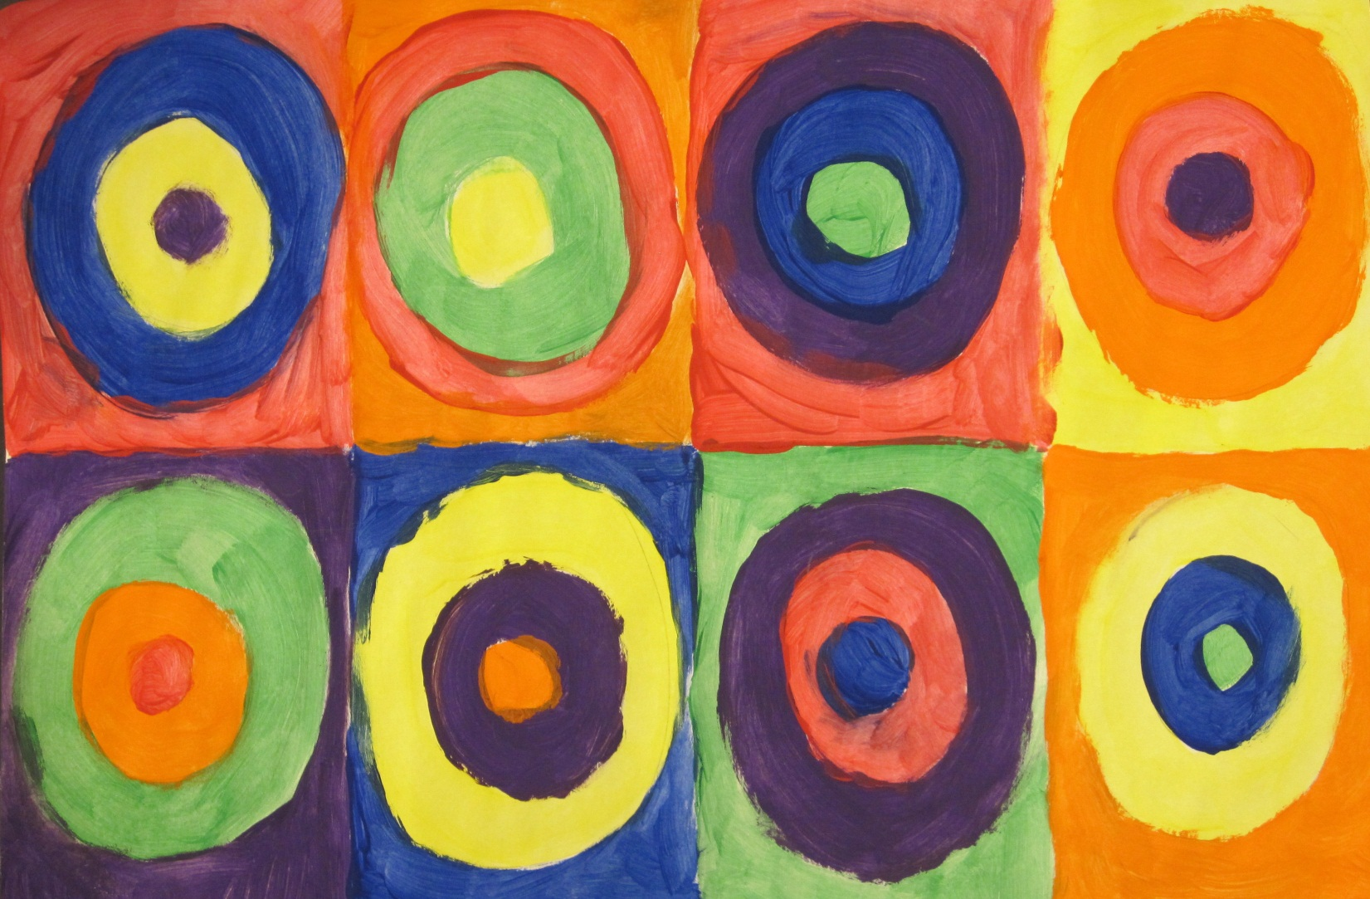

A. Where Art Classroom

B. Grade/Student Level 1st/2nd Grade

C. Class/Date/Times One 50 minute period

D. Room Description

**II. CURRICULUM CONTENT:**

**Creative Expression and Communication**

Students create artworks that demonstrate understanding of materials, processes, tools, media, techniques and available technology. They understand how to use art elements, principles and images to communicate their ideas in a variety of visual forms.

**1st Grade Level Indicators:**

1. Demonstrate beginning skill in the use of art materials and tools.

**2nd Grade Level Indicators:**

1. Demonstrate increasing skill in the use of art tools and materials.
2. **General Description**

Students will use tempera paints to create a painting inspired by the artwork *Color Study ~ Squares with Concentric Circles* by Russian artist Wassily Kandinsky.

1. **Cognitive Goals: (Bloom)**
2. Understand art element of color
   1. Identify primary and secondary colors
   2. Use primary and secondary colors in a painting
3. Understand the art principle of pattern
   1. Create a pattern of repeating circles
4. Understand the term “concentric circle”
   1. Create concentric circles in a painting
5. **Affective Goals: (Krathwohl)**
6. Follows directions well
   1. Cooperates with teacher’s instructions quickly
   2. Asks questions when necessary
   3. Completes task as instructed
7. Works independently
   1. Able to complete task without seeking excessive assistance
   2. Does not disrupt classmates with chatter or play
8. Works cooperatively
   1. Shares materials
   2. Shares space
9. **Psycho/Motor Skill Goals (Simpson)**
10. Draws concentric cirles
    1. Controls pencil by grasping between forefingers and thumb
    2. Draws circles inside one another with even distances all around
11. Paints with tempera
    1. Dips brush in paint and spreads paint in thin layer on paper
12. Creates divisions in paper by folding
    1. Folds paper in half, then in half again each direction to create 8 divisions
13. **Vocabulary: defined**

* **Primary colors** – red, yellow, blue. Used to make all other colors. Cannot be mixed.
* **Secondary colors** – orange, purple, green
* **Concentric circles** – circles inside of circles that get smaller towards the center
* **Wassily Kandinsky**—Russian artist who worked with color

1. **Materials/Tools: quantity and quality specified**

**Note: materials listed for 80 students, 4 classes of 20**

* 80 sheets white sulfite paper, 12” x 18”
* 25 number 2 pencils
* 6 plastic palettes
* 25 large bristle brushes
* one container each red, yellow, and blue tempera (magenta ideal for mixing violet)
* newspapers for covering tables

1. **Teacher Resources**

* Teacher exemplar
* Slide of Kandinsky’s Color Study of Circles in Squares

1. **Bibliography**
   1. [www.odc.state.oh.us/curriculum-assessment/ci/](http://www.odc.state.oh.us/curriculum-assessment/ci/)
   2. [www. arteducators.org](http://www.arteducators.org)
   3. [www.oaea.org](http://www.oaea.org)

**III. TEACHING STRATEGIES**

1. **Motivation:** (**Artistic**, Intellectual, Imaginative, Kinesthetic) describe

Kids will get to paint with bright colors in a “no-fail” painting (anyone can make circles!)

1. **Methodology/Procedures (Hunter)**
2. T sets up before class
   1. T sets out newspaper at ends of table
   2. T sets out white sulfite paper
   3. T puts one color of paint in each of six palettes
3. T introduces project
   1. T shows slide of Kandinsky asks S to name some colors they see in the painting
   2. T asks S why an artist would make a painting just of circles, leads mini aesthetics discussion (brief)
4. T demo at center table
   1. T folds paper for sections
      1. T folds paper in half, then in half again each direction to produce 8 sections
      2. In each section, T draws 3 concentric circles lightly in pencil
5. S begin project
   1. T has volunteer distribute paper
   2. S begin project as demoed by T (folding, drawing circles)
6. T demos painting
   1. T uses each color paint to fill in 5 or 6 random circles
   2. T tells S that each table will have one color of paint, and S will have 5 minutes at each table to paint 4 circles
7. S paint
   1. S cover tables with newspaper
   2. T has S volunteer distribute brushes
   3. T puts one palette at each table, has S paint 5 or 6 random circles as instructed
   4. After 5 minutes, T calls time
      1. Gives S 30 seconds to finish current circle
   5. S rotate to next table clockwise around room, leaving brush at palette but bringing painting with
   6. S repeat painting process until paper is filled.
8. Cleanup
   1. S leave paintings to dry at rack
   2. S discard newspaper
   3. S clean brushes and palettes, etc.

C. Discipline Model Description (Canter)

**IV. ASSESSMENT/EVALUATION:** critical analysis of observed results

**Observation Criteria:**

* Student is on-task and working
* Student does not distract others
* Student shares materials when appropriate

**Oral Assessment:**

T quizzes S orally for vocabulary identification of terms “concentric circles,” primary and secondary colors, and “Kandinsky”



**V. COMMENDATIONS AND RECOMMENDATIONS FOR FUTURE LESSONS**

* Plan on finishing project within one day. If not possible, then plan learning extension.
* Spend less time on art criticism at start of lesson in order to finish within one day
* Pre-cover tables with newspaper for efficiency