**Lesson Plan/Format**

NAME Dina Hoeynck COURSE INSTRUCTOR

**I. PROJECT TITLE:**  Exquisite Corpse

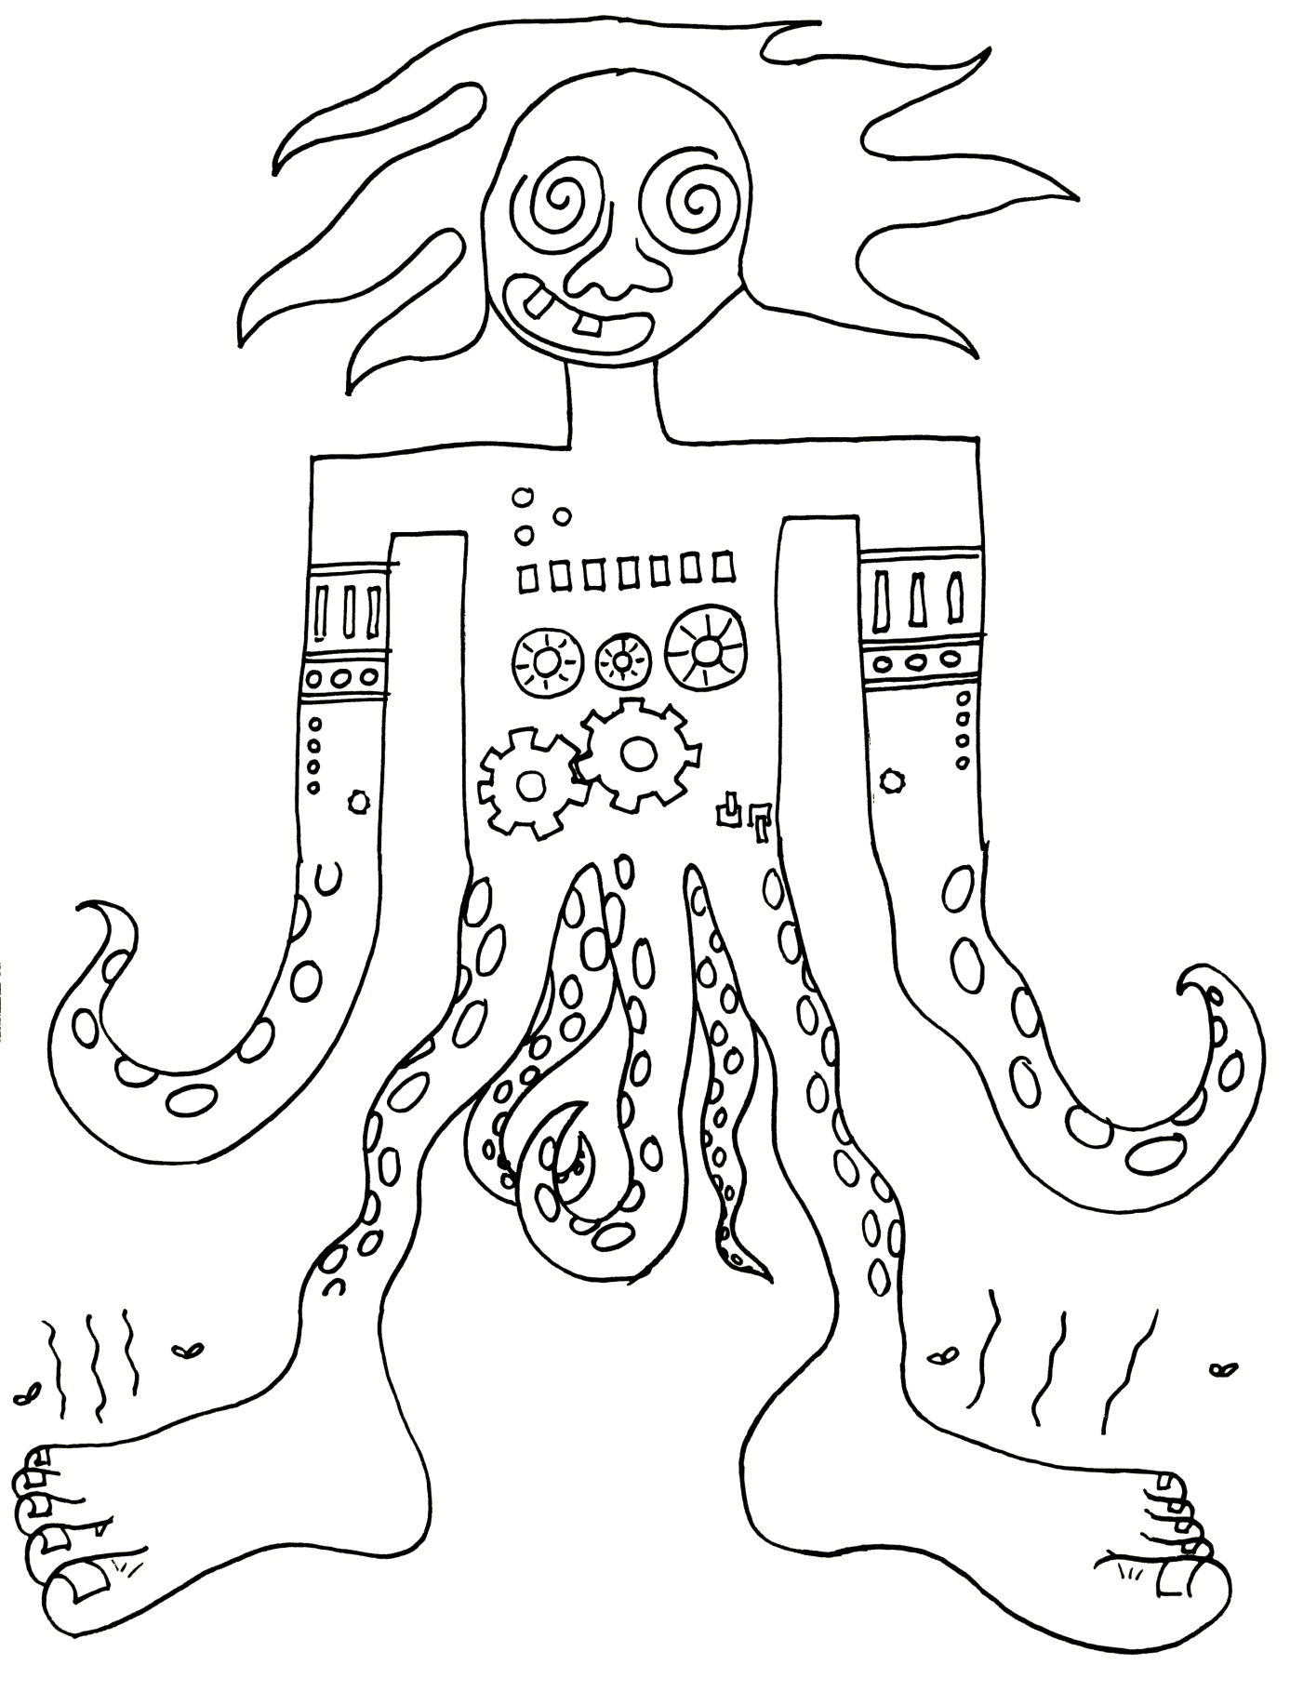

A. Where Art Classroom

B. Grade/Student Level 1st/2nd Grade

C. Class/Date/Times One 60 minute period

D. Room Description Art Room

**II. CURRICULUM CONTENT:**

**Creative Expression and Communication**

Students create artworks that demonstrate understanding of materials, processes, tools, media, techniques and available technology. They understand how to use art elements, principles and images to communicate their ideas in a variety of visual forms.

**1st Grade Level Indicators:**

1. Demonstrate beginning skill in the use of art materials and tools.
2. Identify visual art elements and principles using art vocabulary.
3. Explore and use a range of subject matter (e.g., people, places, animals and nature) to create original works of art .

**2nd Grade Level Indicators:**

1. Demonstrate increasing skill in the use of art tools and materials.
2. Create artworks based on observation of familiar objects and scenes in the environment.
3. **General Description**

Students will view selected surrealist artworks and be introduced to the term “Surrealism.” Students will then collaborate to create exquisite corpse drawings. If they get stuck on what to draw, they may pull a pre-written prompt out of a random chance jar.

1. **Cognitive Goals: (Bloom)**
2. Understand art element of line
   1. Draw using contour lines
   2. Identify lines verbally
   3. Understand that lines have direction and length, and can be straight, curvy, etc.
3. Understand art principle of variety
   1. Create variety by sharing drawing tasks with others
4. Understand Surrealism
   1. Understand surrealist principles of chance
   2. Engage in surrealist activity of exquisite corpse drawing
5. **Affective Goals: (Krathwohl)**
6. Follows directions well
   1. Cooperates with teacher’s instructions quickly
   2. Asks questions when necessary
   3. Completes task as instructed
7. Works independently
   1. Able to complete task without seeking excessive assistance
   2. Does not disrupt classmates with chatter or play
8. Works cooperatively
   1. Shares materials
   2. Shares space
9. **Psycho/Motor Skill Goals (Simpson)**
10. Folds paper in quarters
    1. Lines up opposite edges of paper and creases fold
    2. Repeats a second time
    3. Unfolds to reveal 4 even sections
11. Draws with pencil
    1. Holds pencil between thumb and first two fingers
12. Traces with Sharpie
    1. Presses lightly with sharpie to not smash tip
    2. Traces over pencil outline accurately
13. Erases remaining pencil marks
    1. Moves big eraser to erase pencil marks
14. **Vocabulary: defined**

**Line:** The connection between 2 points. They can be long or short, wide or skinny, curvy or straight.

**Contour Line:** an outline

**Variety:** Having lots of different things in your art

**Surrealism:** An art movement that used images from dreams and random chance.

1. **Materials/Tools: quantity and quality specified**

**Note: materials listed for 80 students, 4 classes of 20**

* 80 sheets (plus overage) white sulfite paper, 12” x 18”
* 25 pencils
* 20 erasers
* 25 sharpie markers
* Crayola marker classpack (optional)

1. **Teacher Resources**

* Slideshow of Surrealist art
* Cut-up word prompts
* Teacher exemplar

Activity Sheet: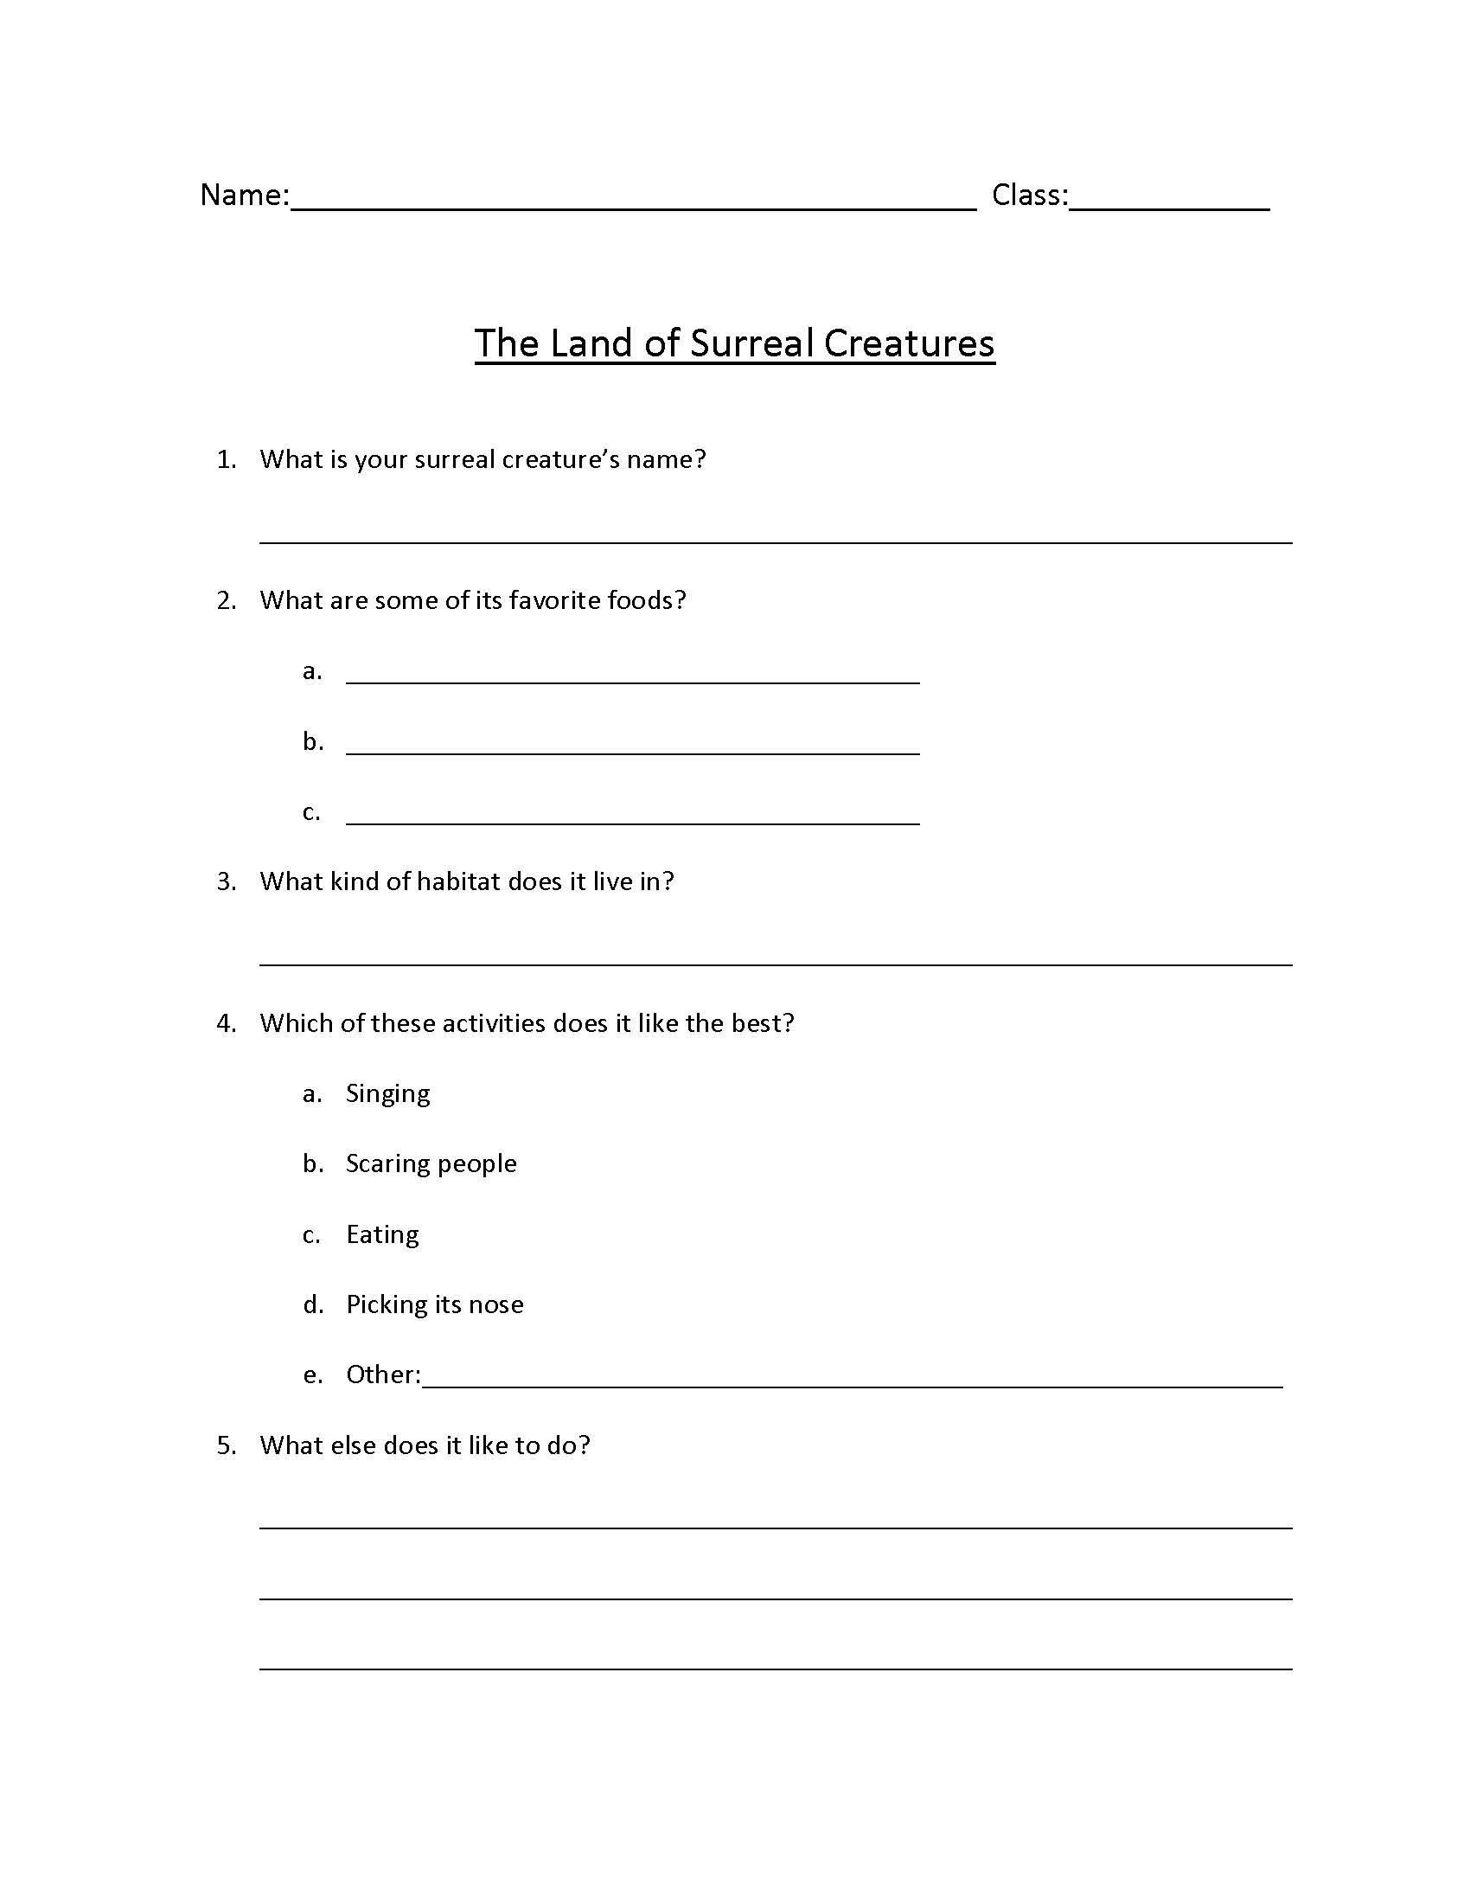

­

1. **Bibliography**
   1. [www.odc.state.oh.us/curriculum-assessment/ci/](http://www.odc.state.oh.us/curriculum-assessment/ci/)
   2. [www. arteducators.org](http://www.arteducators.org)
   3. [www.oaea.org](http://www.oaea.org)

**III. TEACHING STRATEGIES**

1. **Motivation:** (Artistic, Intellectual, **Imaginative**, Kinesthetic) describe

Kids will get to imagine all sorts of different crazy characters.

1. **Methodology/Procedures (Hunter)**
2. T sets up
   1. T places a container with cut-up word prompts at each table
   2. T connects computer and projector for surrealism slideshow
3. T shows slideshow
   1. T explains that surrealists were inspired by dreams
   2. T asks S to think about if they’ve ever had a really crazy dream
4. Distribution of supplies
   1. T hands stack of paper to each table, has S take one and pass it on
5. S write names on back of paper
6. T lock-steps folding process at front of room
   1. Fold paper like a book
   2. Without unfolding, fold again the same direction
   3. Unfold
7. T tells S they will have 5 minutes for each section
8. T sets timer, tells S to draw head in first section and make sure to connect lines of neck down into next section (demos)
   1. T tells S they can pull one prompt out of the container in center of table if they can’t think of what to draw
9. S draw head
10. T calls time, tells S to pass to the left
    1. Reminds S which side is left
11. T tells each S to draw shoulders and arms in 2nd section without peeking at what first S drew
12. After 5 minutes, T calls time, has S pass to left
13. S draw waist and legs
14. 5 minutes passes, T calls time, has S pass to left
15. S draw feet
16. after 5 minutes, T has S return drawing to original artist, who unfolds and traces over lines with Sharpie
17. S color in with Crayola markers
18. S complete related activity sheet
19. Clean-up
    1. T calls tables one at time to turn in drawings, worksheets, and Sharpies

C. Discipline Model Description (Canter)

**IV. ASSESSMENT/EVALUATION:** critical analysis of observed results

**Observation Criteria:**

* Student is on-task and working
* Student does not distract others
* Student cooperates and shares materials when appropriate

**Oral Assessment:**

While circulating room, T asks S to identify different types of lines in their own drawing.



**V. COMMENDATIONS AND RECOMMENDATIONS FOR FUTURE LESSONS**

* 4 minutes is a better per-round time limit than five minutes.
* Students really enjoy hearing anecdotes about the silly things surrealists did—try to dig up a few more school-appropriate surrealist anecdotes to share during drawing