Lesson Plan/Format

NAME Dina Hoeynck COURSE INSTRUCTOR

I. PROJECT TITLE: Chinese Brush Painting

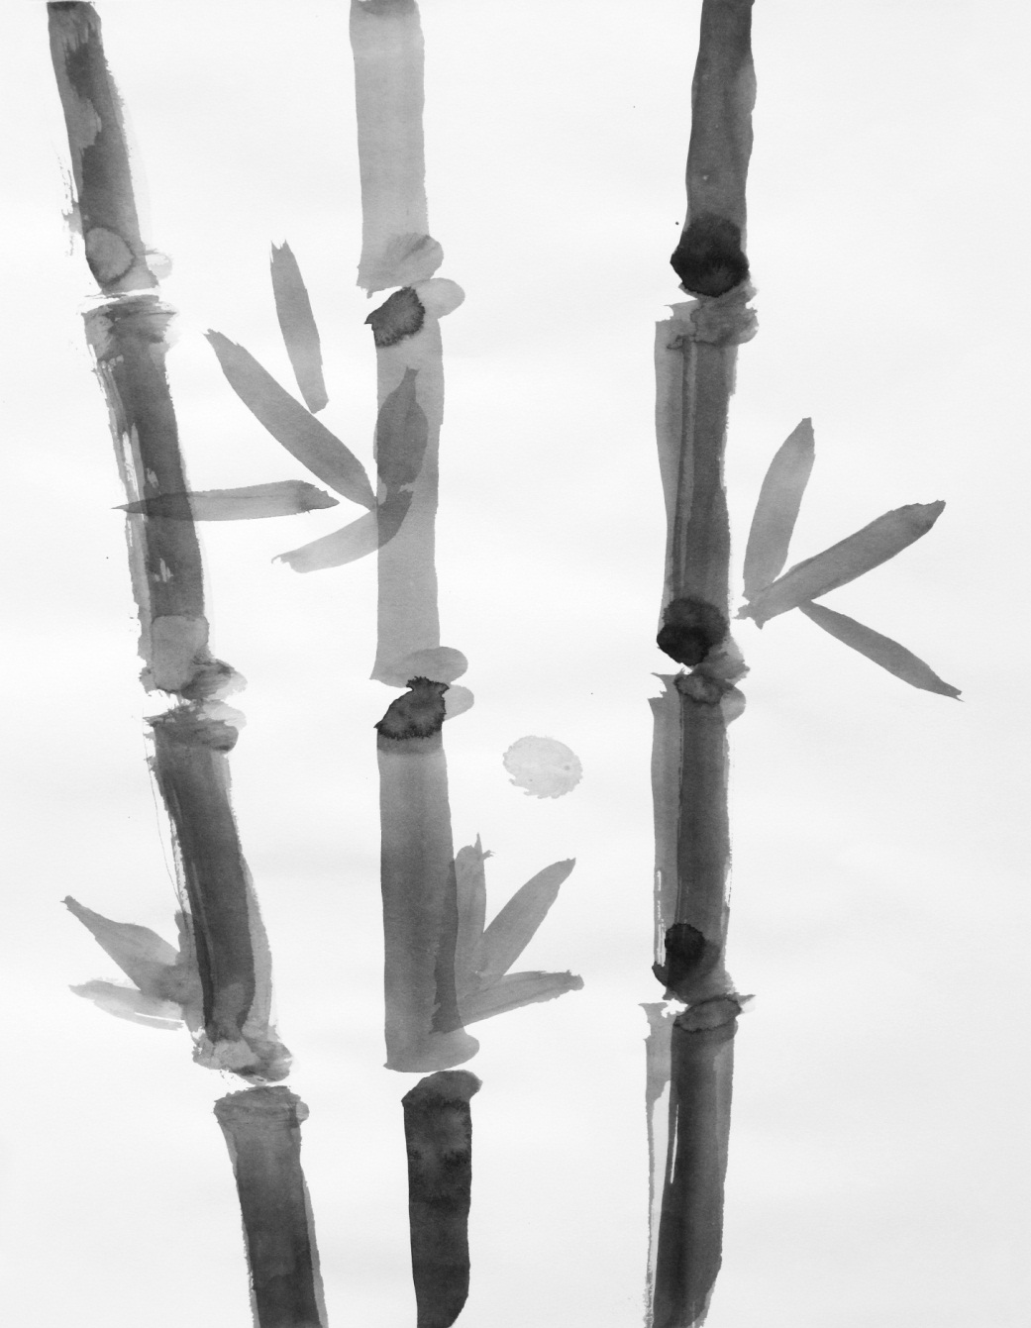

A. Where Art Classroom

B. Grade/Student Level 6th Grade

C. Class/Date/Times Two 50 minute periods

D. Room Description

II. CURRICULUM CONTENT:

Creative Expression and Communication
Students create artworks that demonstrate understanding of materials, processes, tools, media, techniques and available technology. They understand how to use art elements, principles and images to communicate their ideas in a variety of visual forms.
Grade Level Indicators:

Demonstrate skill in changing (e.g., exaggerating and transforming) natural forms for expressive purposes.

Use observation, life experiences and imagination as sources for visual symbols and images.

Recognize and demonstrate the qualities and characteristics of craftsmanship in original works of art.

- General Description

Students will analyze the use of line and economy in traditional Chinese brush painting, and then create an original painting using that style that depicts a simplified natural form.

- Cognitive Goals: (Bloom)

- Understand Chinese brush paintings
  - Analyze Chinese brush paintings in group discussion
  - Apply Chinese brush painting style in an original work

- Understand element of line
  - Identify line orally in group discussion of Chinese brush paintings
  - Apply line in an original work of art
  - Understand various properties of line (weight, direction, value)

- Understand principle of economy
  - Identify economy orally in group discussion of Chinese brush paintings
  - Apply principle of economy in simplifying an image from nature
  - Identify economy verbally in own work

- Affective Goals: (Krathwohl)

- Appreciate the simple elegance of Chinese brush paintings
  - Listen attentively during slideshow
  - Contribute to discussion of Chinese brush paintings

- Work neatly and cooperatively
  - Clean up after self
  - Share supplies
  - Share workspace

- Work independently
  - Complete all aspects of project without outside pressure
  - Practice skills needed to succeed in project

- Psycho/Motor Skill Goals (Simpson)

- Hold Chinese brushes correctly
  - Brushes are held vertically with the forefinger, middle finger and thumb, palm down.
  - Movement of brush originates in the shoulder, not the wrist.

- Paint with fluid, confident strokes

- Control brush strokes accurately
  - Concentrate on lines they wish to make
  - Execute lines with focus, moving the brush along their intended path

- Vocabulary: defined

Line: An element of art; a mark that spans a distance between two points.
Weight: The thickness or thinness of a line.
Value: The lightness or darkness of a line.
Direction: The angle of the line as it travels across the page.
Economy: A principle of art; using the bare minimum of marks to communicate an idea.
Contour: the outline of an image.
Fluid (as in line): Smooth and flowing; graceful.

- Materials/Tools: quantity and quality specified

    - 15 Chinese calligraphy brushes
    - 45 sheets white drawing paper, 16” x 24”
    - Newsprint pad for planning/practice
    - Black Sumi ink
    - Containers for water
    - Plastic painting palettes
    - Paper towels
    - Reference images, either from magazines or the internet

- Teacher Resources
  - Digital projector or smart board
  - Powerpoint slideshow of Chinese brush painting
  - Laptop or other computer for running slideshow
  - Easel
  - Teacher exemplars

- Bibliography
  - www.odc.state.oh.us/curriculum-assessment/ci/
  - www. arteducators.org
  - www.oaea.org
  - www.artstor.org
  - Personal Website of Betty J Sarantos: http://www.croquetartist.com/chinese.htm

III. TEACHING STRATEGIES
- Motivation: (Artistic, Intellectual, Imaginative, Kinesthetic) describe

- Painting with ink offers artistic motivation
- Intellectual challenge of applying principle of economy to chosen subject.

- Methodology/Procedures (Hunter)

- T shows slideshow of Chinese brush paintings
  - T asks S if the images look lifelike
    - S respond
  - T asks how they are different from what you see in the world
    - S Respond
  - T introduces concepts of line and economy
    - T explains how in Chinese brush painting, natural forms are simplified to their most basic lines.
    - T asks S to describe the lines in a painting
      - Where do you see short lines?
      - Choppy or rough lines?
      - Long, fluid lines?
      - Are the lines different values?
- T guides students in practice brushwork
  - T distributes newsprint, brushes, ink, and water
  - T demonstrates how to hold brush
    - Brush is held vertical to the page
    - Brush is gripped loosely between the thumb and first two fingers, palm down
    - Movement of brush originates in the shoulder
    - T checks visually that all students hold brushes correctly
  - T leads guided practice in markmaking
    - T works on easel at front of room to demonstrate different marks, and has students follow along at their seats
    - T and S pour some sumi ink into plastic palettes
    - T and S wet brushes, wiping excess water from brush on lip of water container
    - T and S saturate first third of brush in ink
    - T guides S in making different kinds of lines
      - Long straight lines
      - Long wavy lines
      - Short choppy lines
      - Thin lines
      - Fat lines
      - Lines varying in width
        - T demonstrates how line width is controlled by pressure
    - T repeats this for lines of varying value, explaining how S can lighten the value of ink by mixing it with more water

***********************DAY TWO***********************

- T directs S to find source images for original paintings
  - Images may be found on internet or magazines
  - Images must be something from nature—plant or animal.
- S create paintings on good paper
  - T instructs S to create several paintings of their chosen subject
    - T encourages S verbally to experiment with different approaches to economy, leaving out or retaining different details of an image
    - T encourages S verbally to experiment with different types of line
- S sign paintings and begin self-assessment and teacher feedback form
  - Self-assessment asks S to pick their best painting in one to two paragraphs describe:
    - Why it is the most successful
    - What kind of lines it contains
    - How it demonstrates the principle of economy
  - Teacher feedback form asks:
    - What did you like best about this project?
    - What did you like least?
    - Tell me the most important thing you learned:
- Class cleans up.
  - Move brushes, water containers, and palettes to sink area
    - Wash brushes in cool water
  - Discard paper towels
  - Wipe down tables
  - Leave finished paintings to dry in isolated area of classroom.

C. Discipline Model Description (Canter)

IV. ASSESSMENT/EVALUATION: critical analysis of observed results

Orally quiz students on definition of economy. Orally ask students to identify how they have used economy in their work.

Observation criteria:
Student is on task
Student does not disturb others from their work

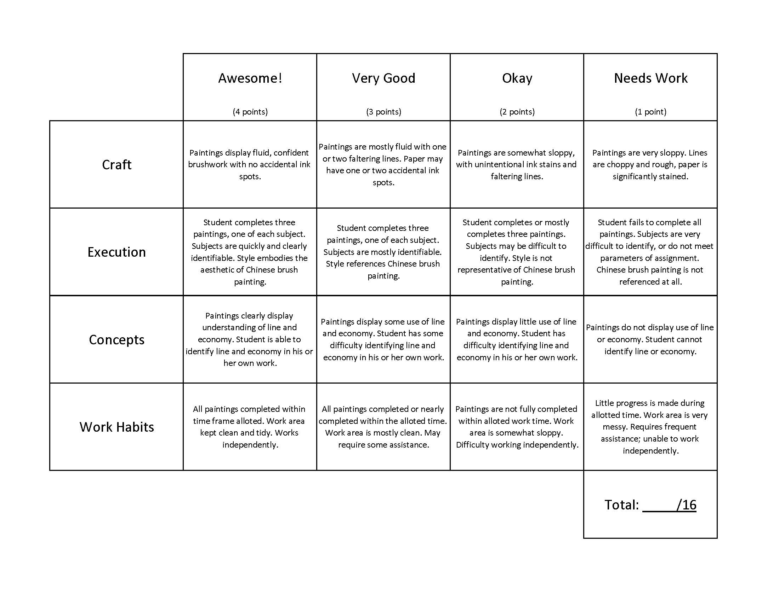

V. COMMENDATIONS AND RECOMMENDATIONS FOR FUTURE LESSONS

- Adaptation made mid-lesson to provide students with reference images, as printing images from computers proved to waste too much time
- Some images worked better than others. Flowers, especially the rose, worked very, very well; it might be worth doing this lesson exclusively of images of flowers, as they lend themselves well to line paintings.
- Describe specific procedures for changing water as it darkens (e.g. designate one person per table)
- Emphasize using ink frugally

